Project Increment-3



Tech Roos Team(Aditya Deshpande, Tej Kiran Meka, Rakesh Reddy Kondakindi, Girish babu)

**Import Existing Services/API's:**

In this increment we used Yahoo Maps API to display the organizations and events near to the locality based on the zip code.

**Detailed Design of Services:**

Design of Mobile client Interface:

We used JQuery mobile to design the Mobile client Interface in this increment.

**Class Diagram:**



**Sequence Diagram:**



**Implementation of Services:**

* The following screen shots are the overview of the features implemented in this project.

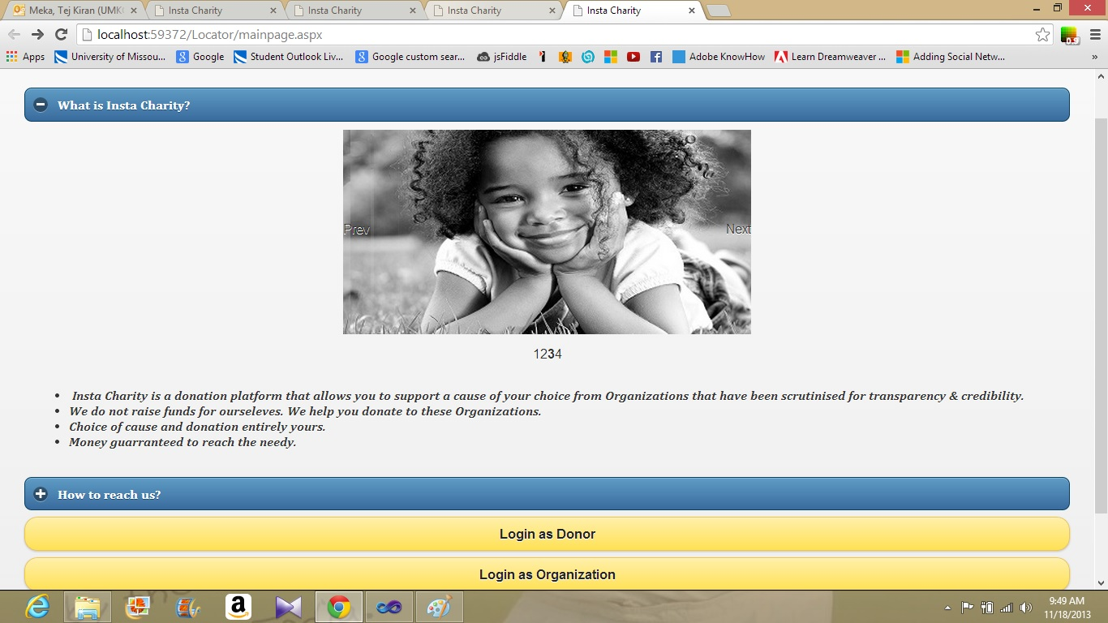

* The above screen shot is the basic overview of the Instacharity main page.
* Below screenshot represents the login page of the donor.

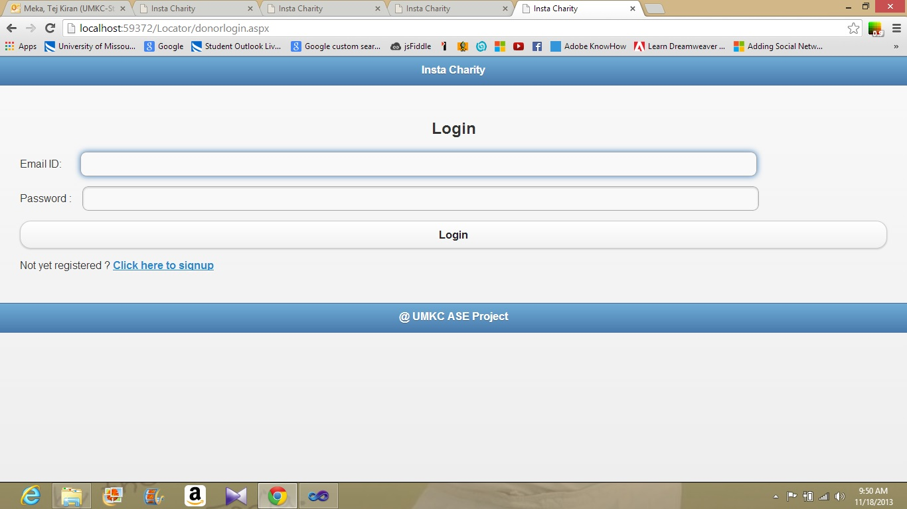

* When the donor login into the site , the below screen shot represents the features available for donor on his home page.

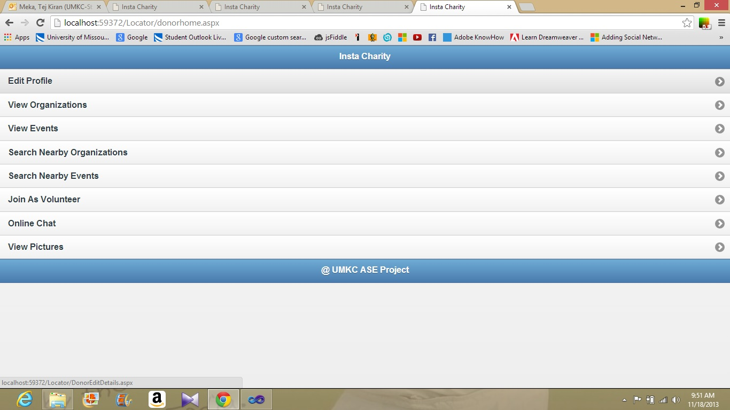

* Donor can view his profile by clicking on the edit profile button provided on the page of donor.

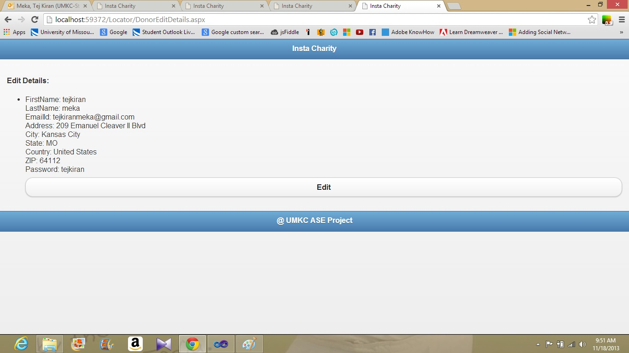

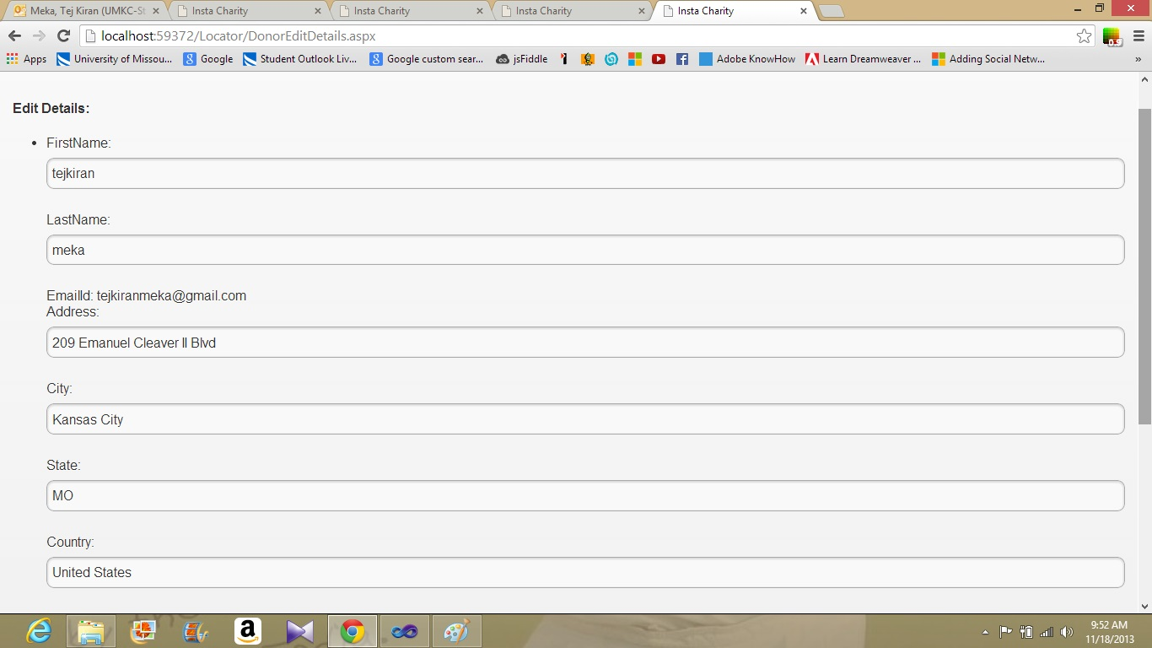

Donor can edit profile by clicking on the edit button provided on the page. After editing details donor can click on update button to update his profile. The following screenshots represents the profile editing feature.

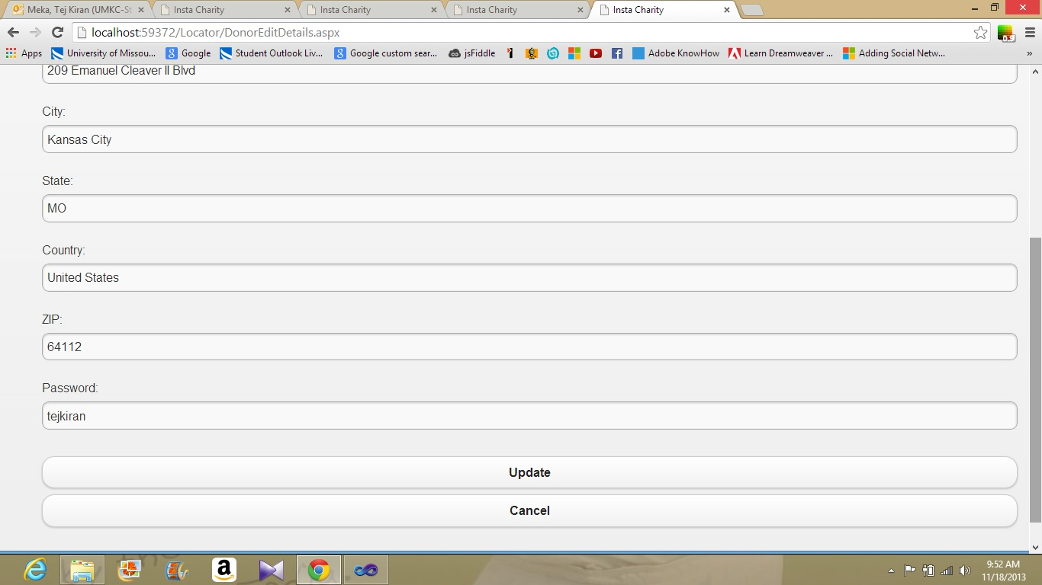

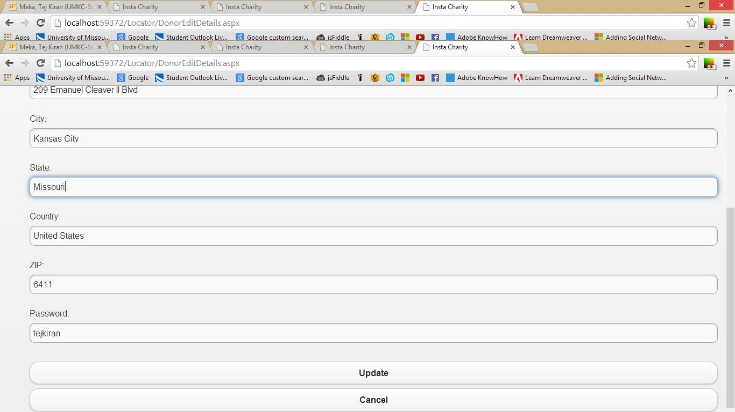

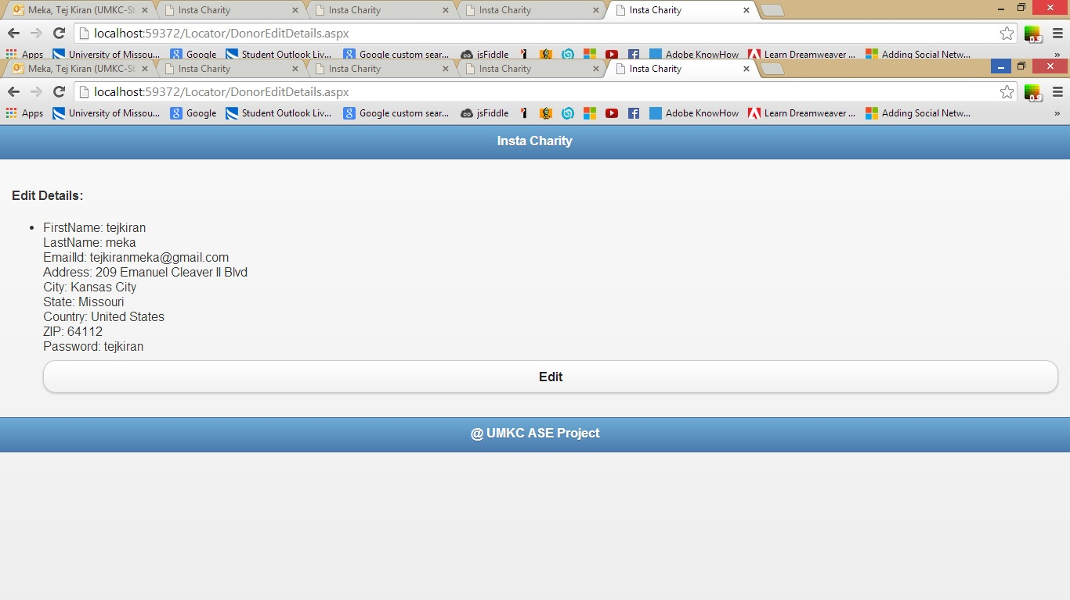

* After editing profile donor will be redirected to view profile section. Donor can view the changes that are made by him/her.

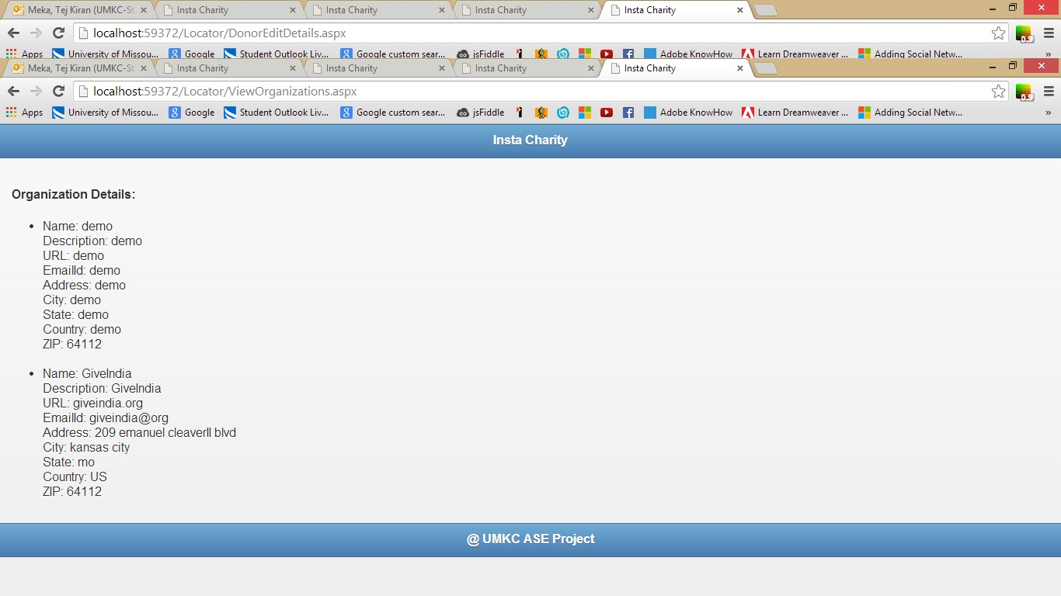

* Donor can view the details of the organizations that are registered with the site.

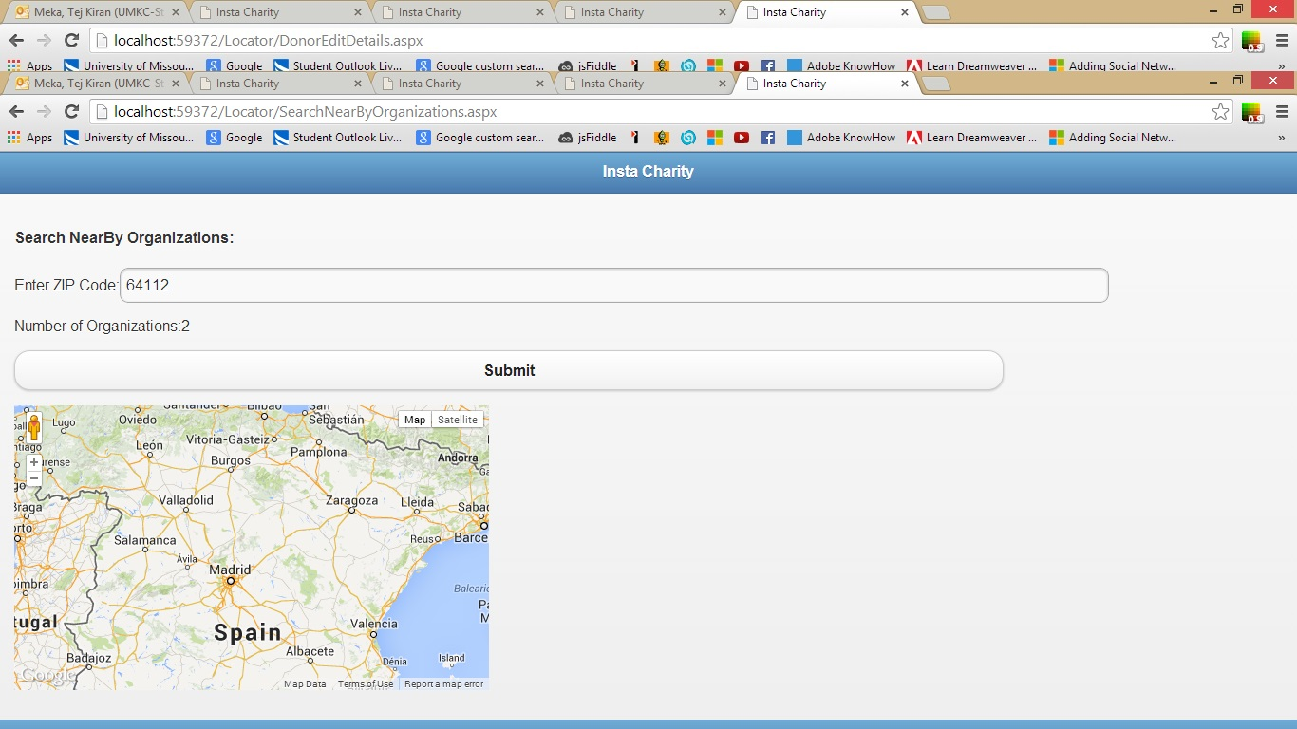

* Donor can search for nearby organizations through ZIP code . We used Yahoo API to search fro nearby organizations.

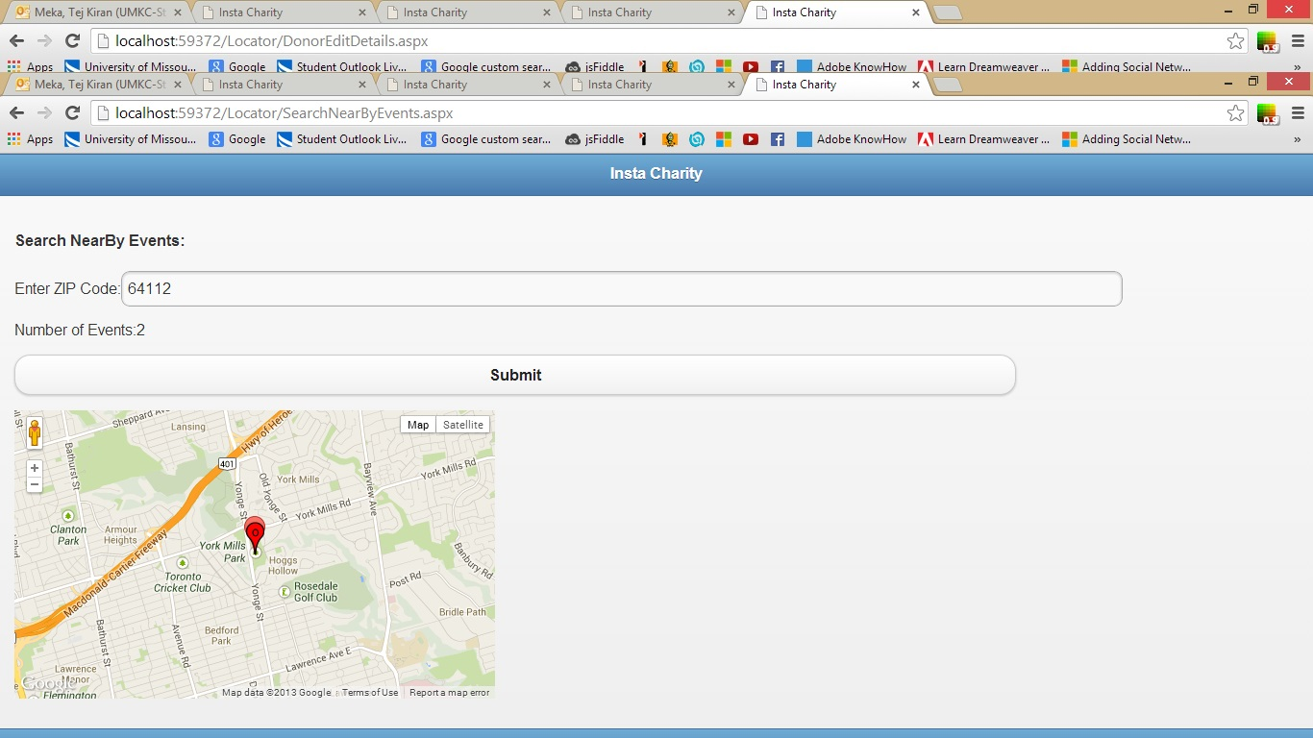

* Donor can search for nearby events through ZIP code.

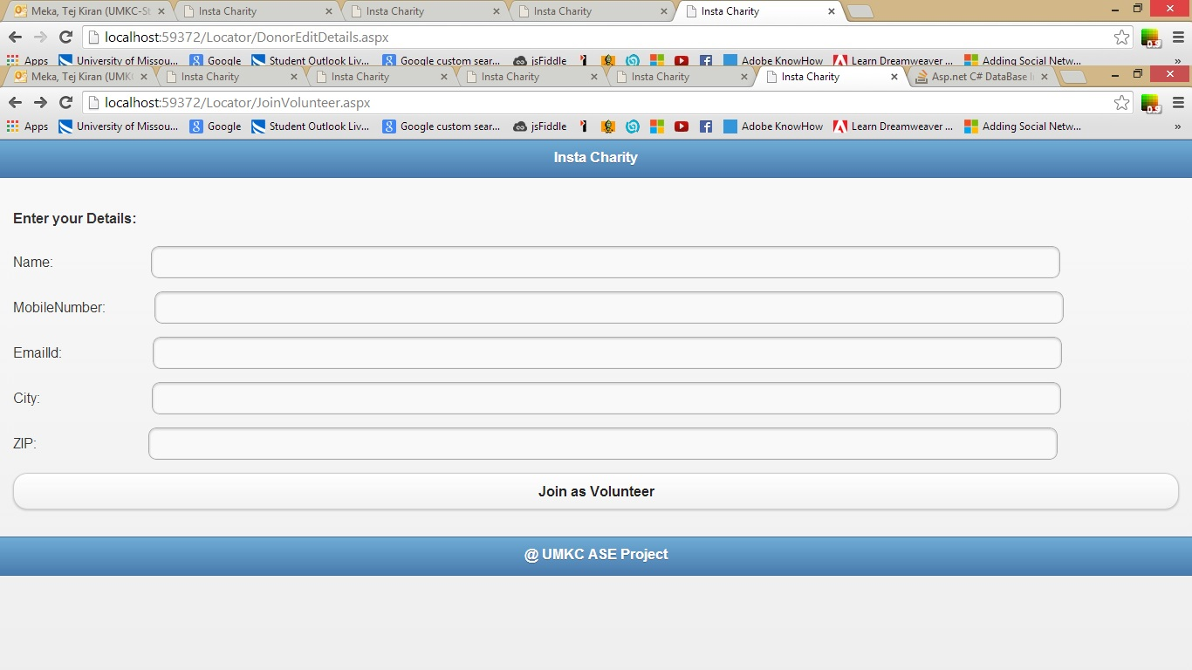

* If a donor is interested to join as volunteer for organizations then he can use the Join as volunteer feature.

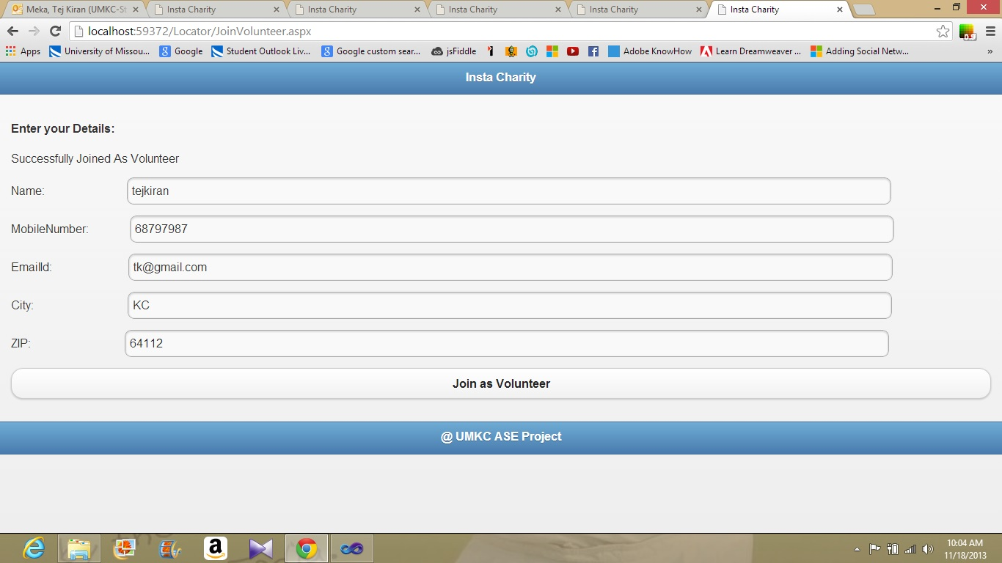

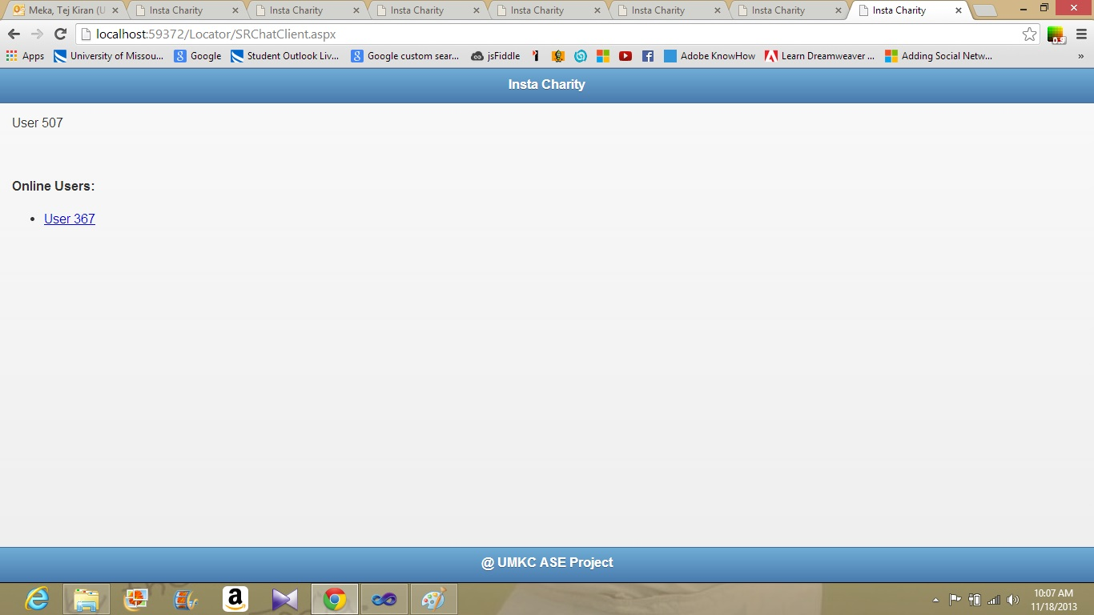

* Donor can interact with the co-donors through the online chat. They can share their views about the events and interact with each other.

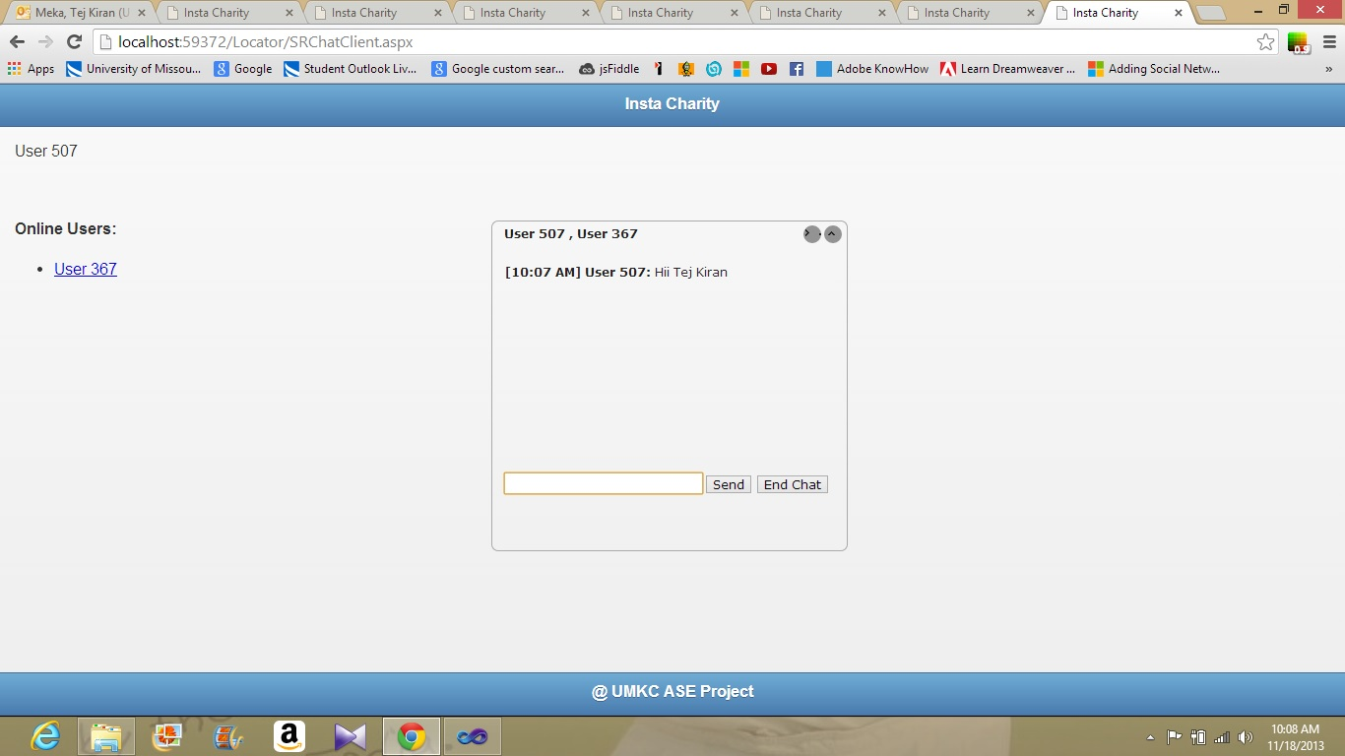

* Below screenshots are the conversation between two online users.

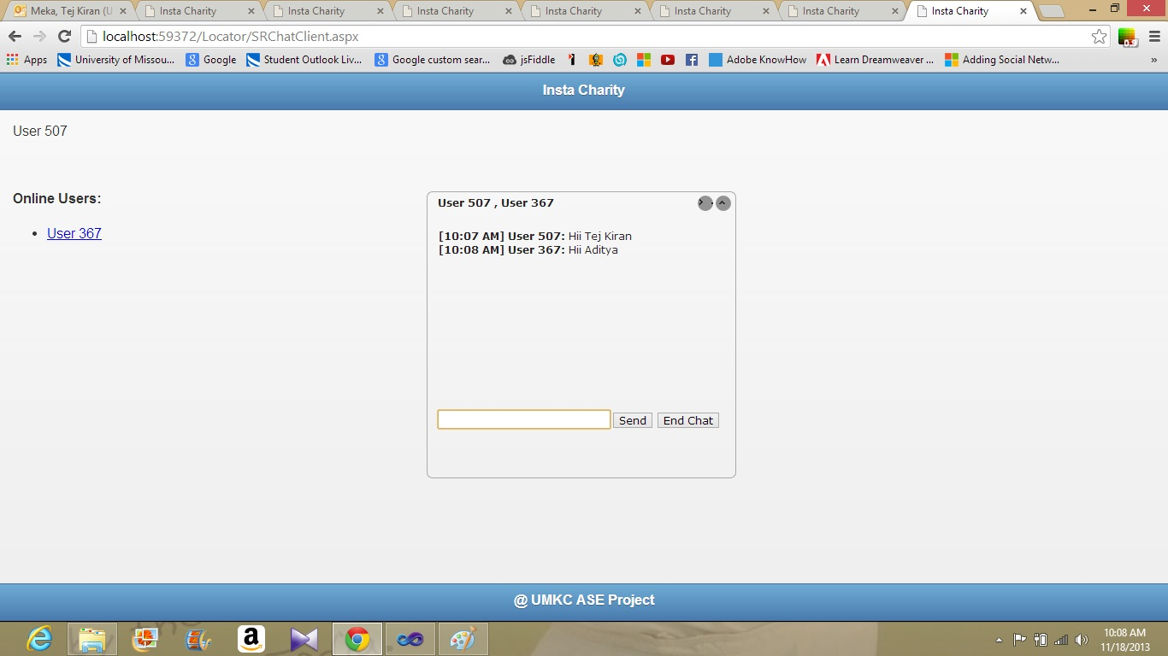

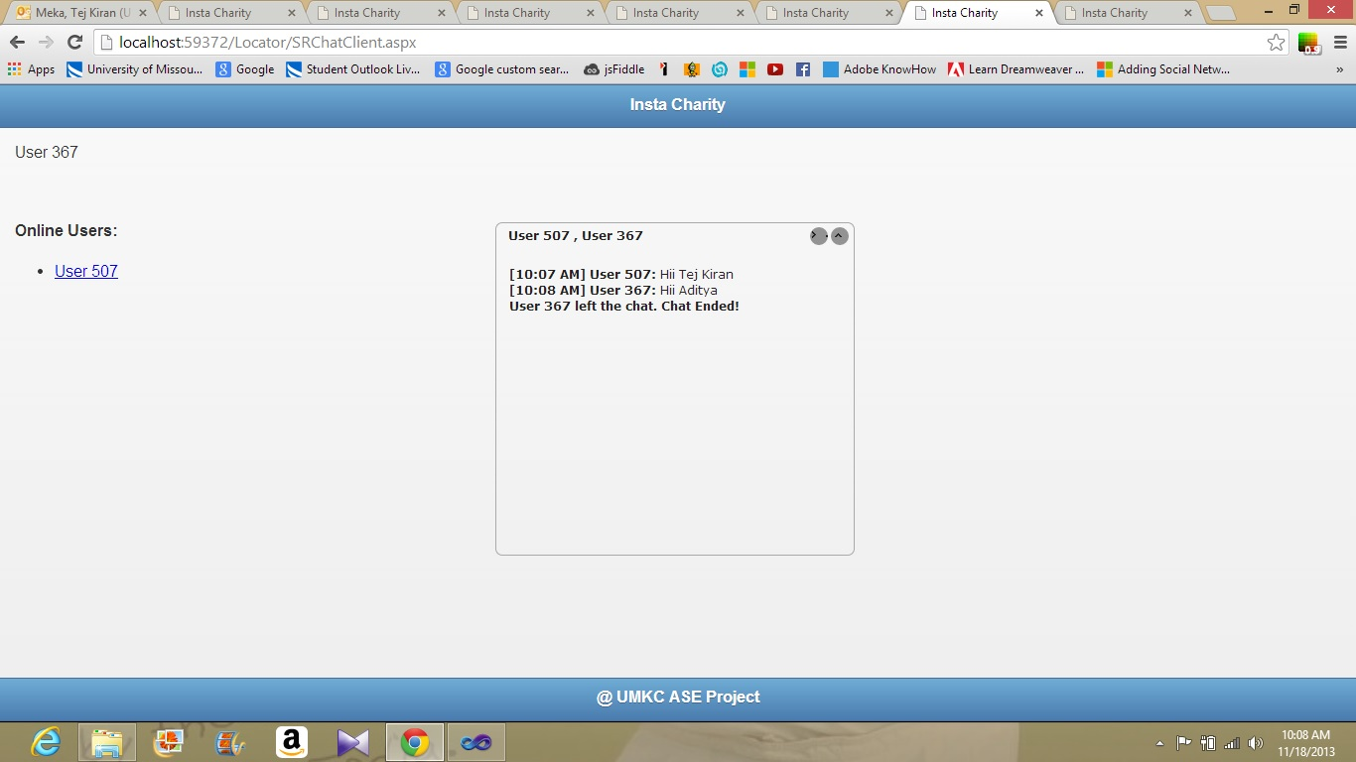

* Donors can view the images of flyers of events or photos of the events.

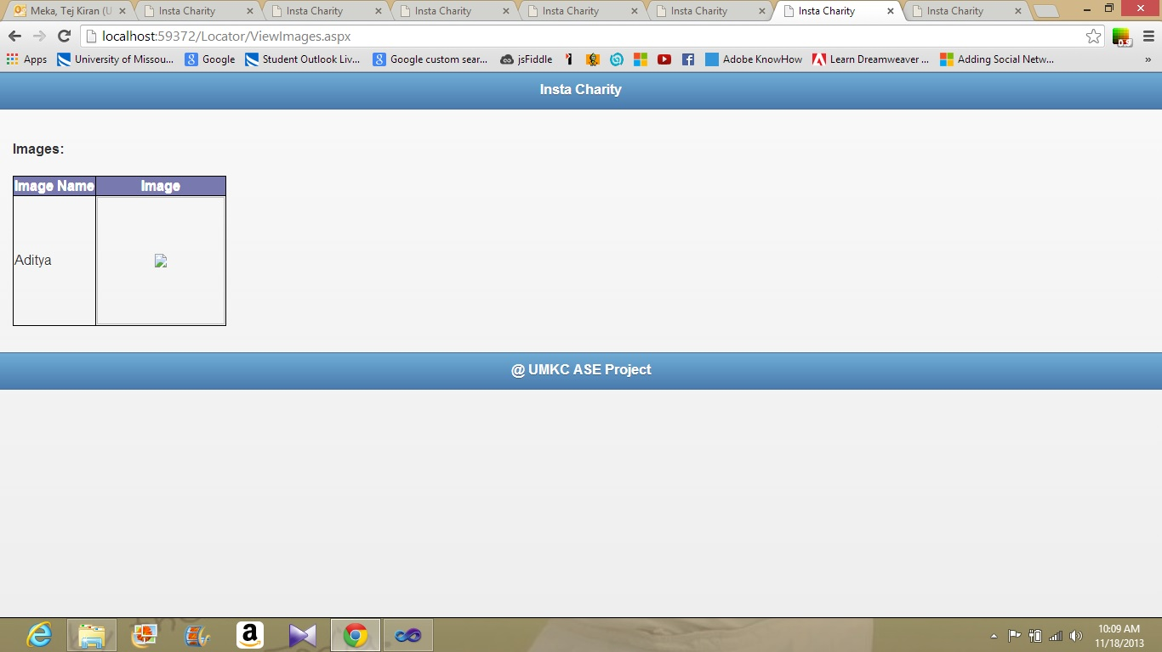

* **From the perspective of the organization:**

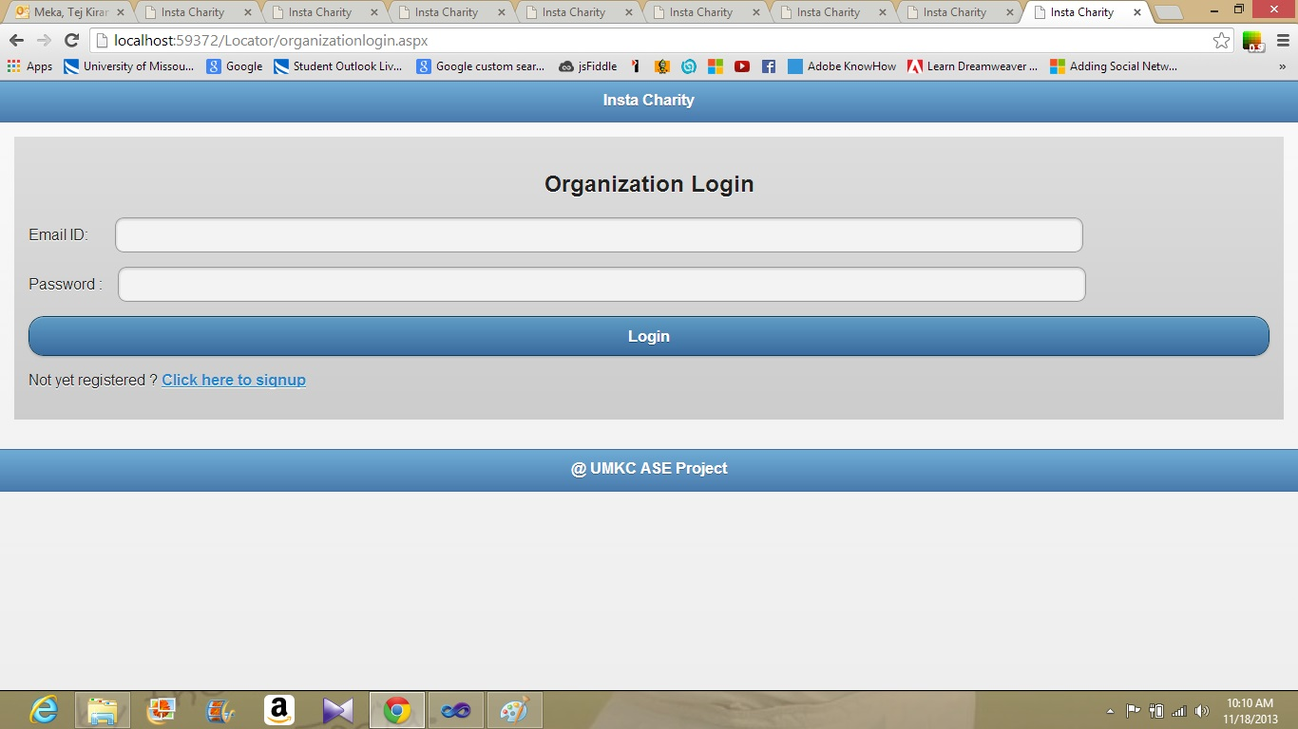

* Above screen shot is the login page of the organization.

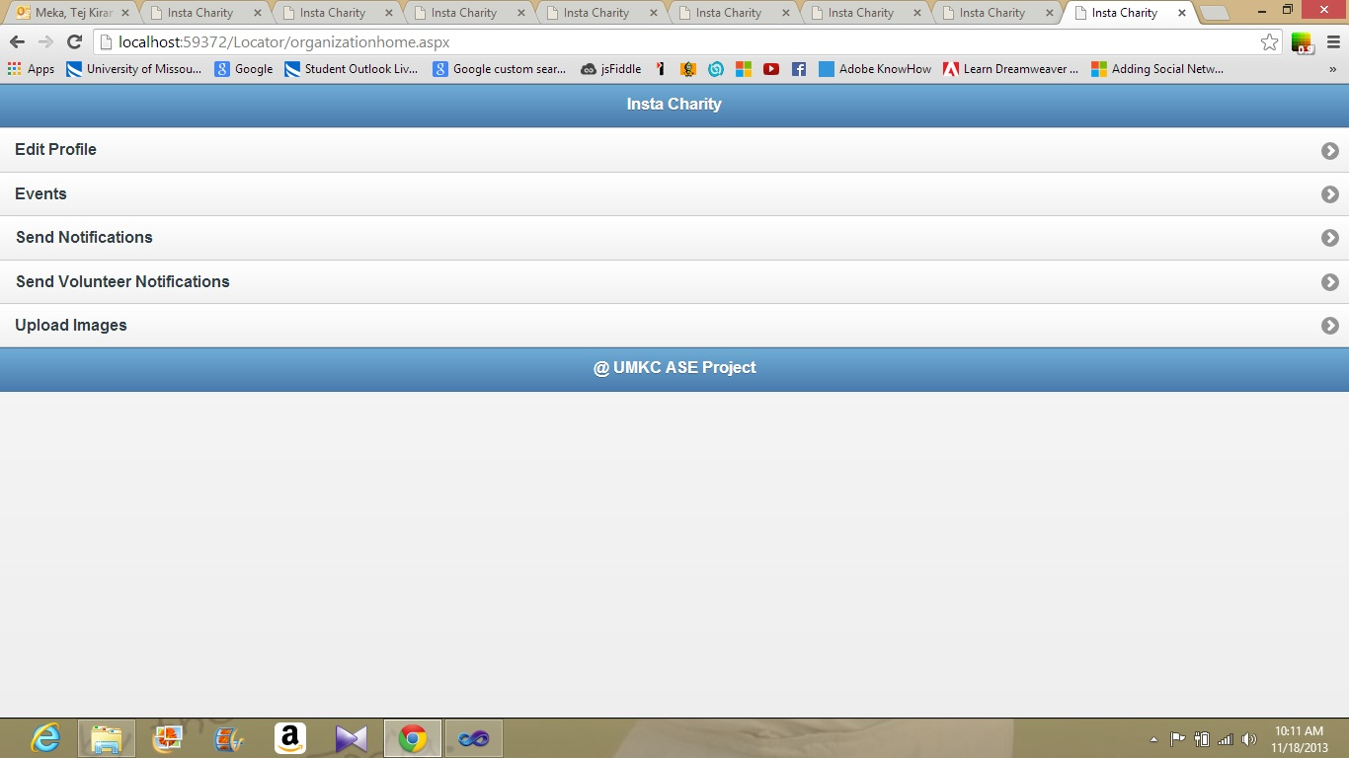

* Above screenshot is home page of an organization.

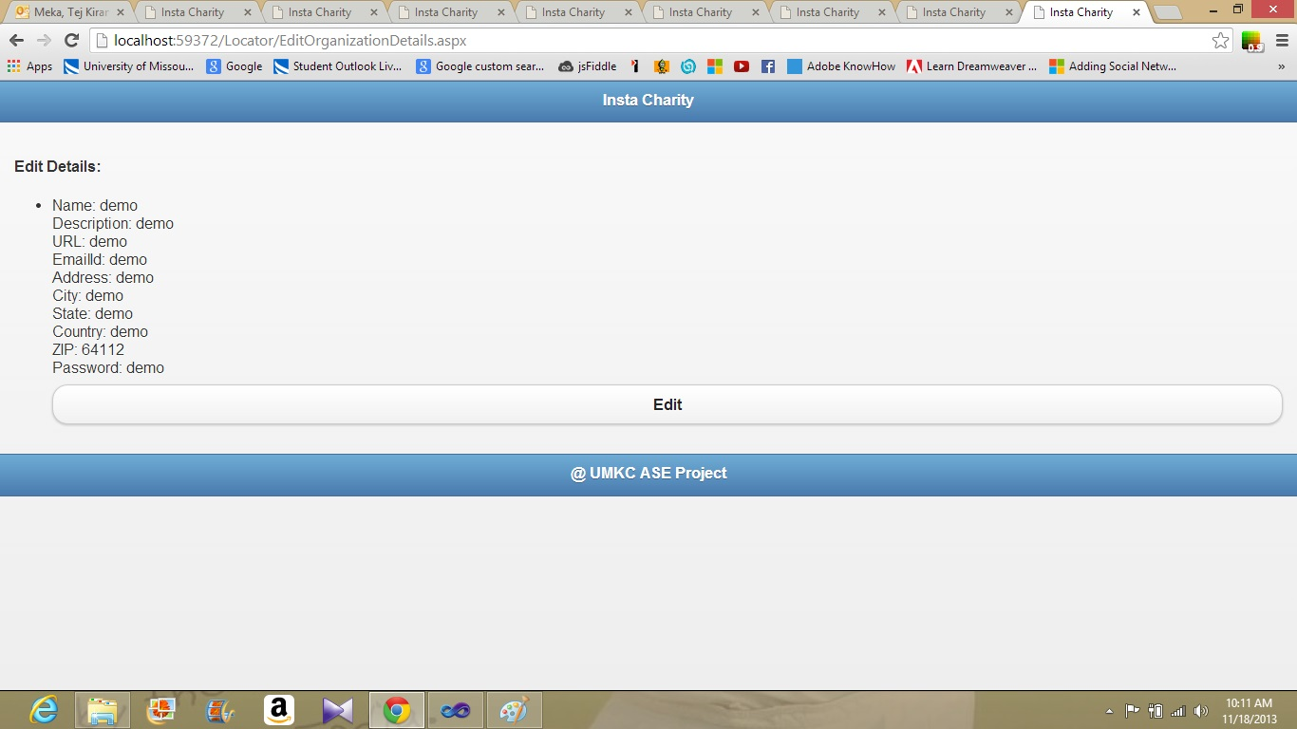

* As like the donor, organization can view their profile and can edit their profile.

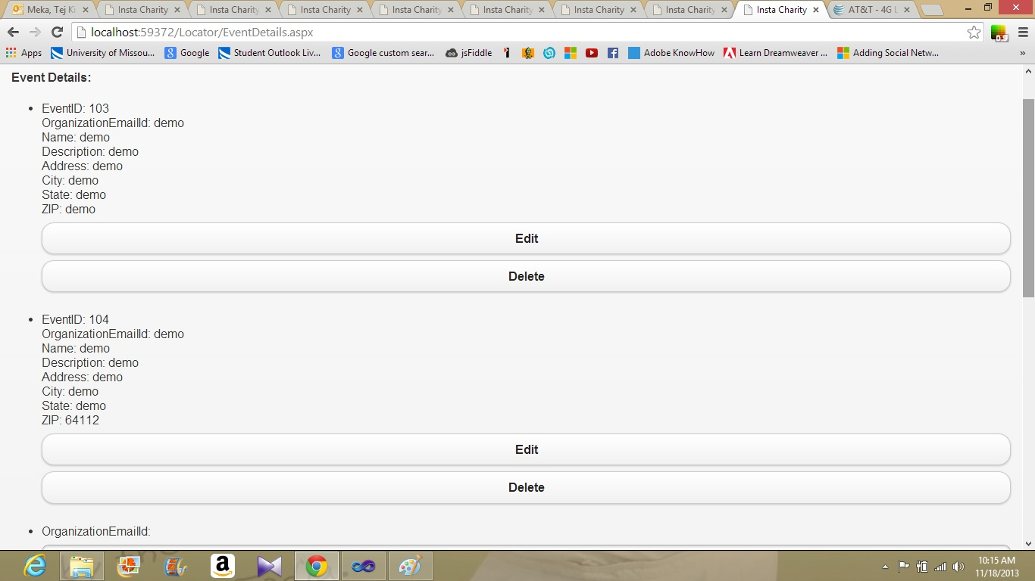

* All the events added by the organization are displayed in events page. Organization can edit or delete the events.

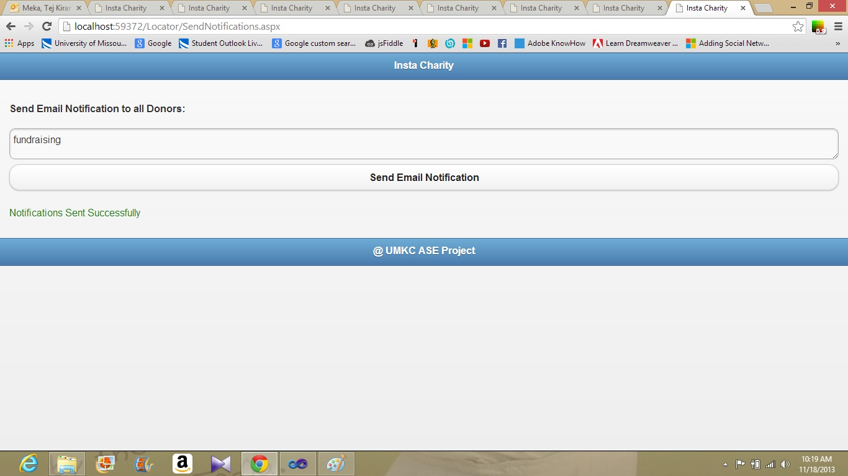

* Organization can send notifications to all donors registered in instacharity website about the information regarding events.

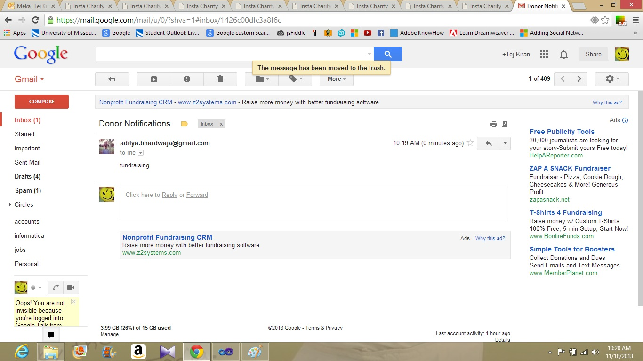

* Above screenshot shows the event notification in the mail of donor.

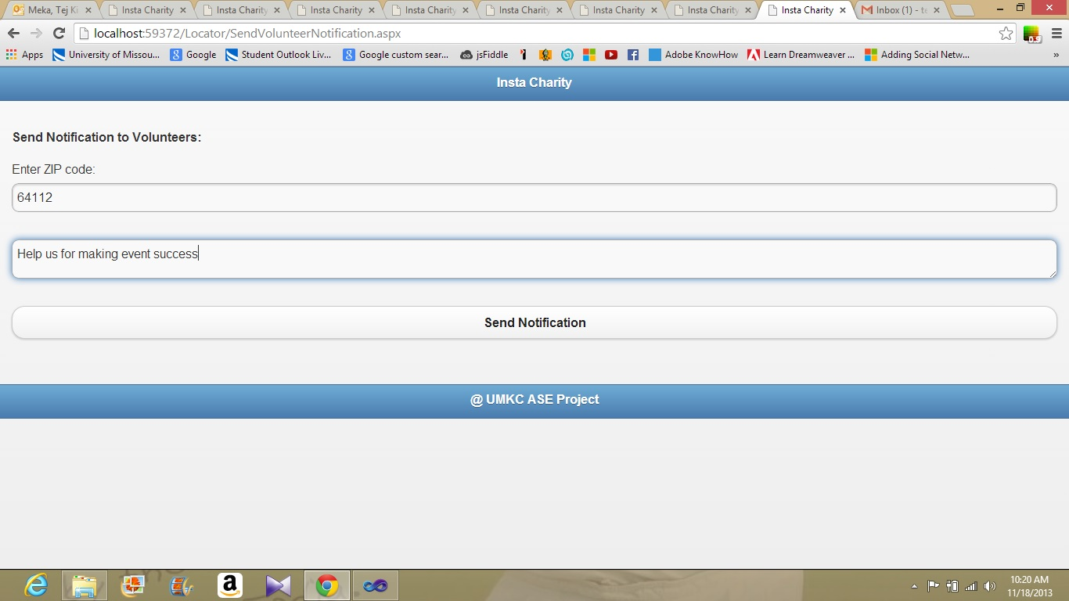

* Organization can send event notification to all volunteers by filtering through zip code to ask for help.

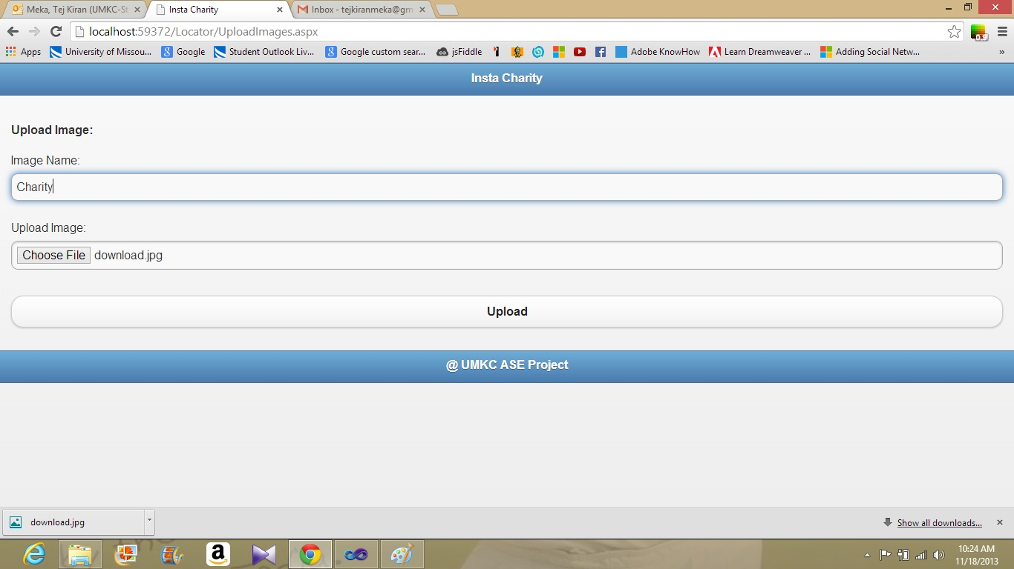

* Organization can upload images like flyers, event posters etc. Donors can view those images through thier profile.

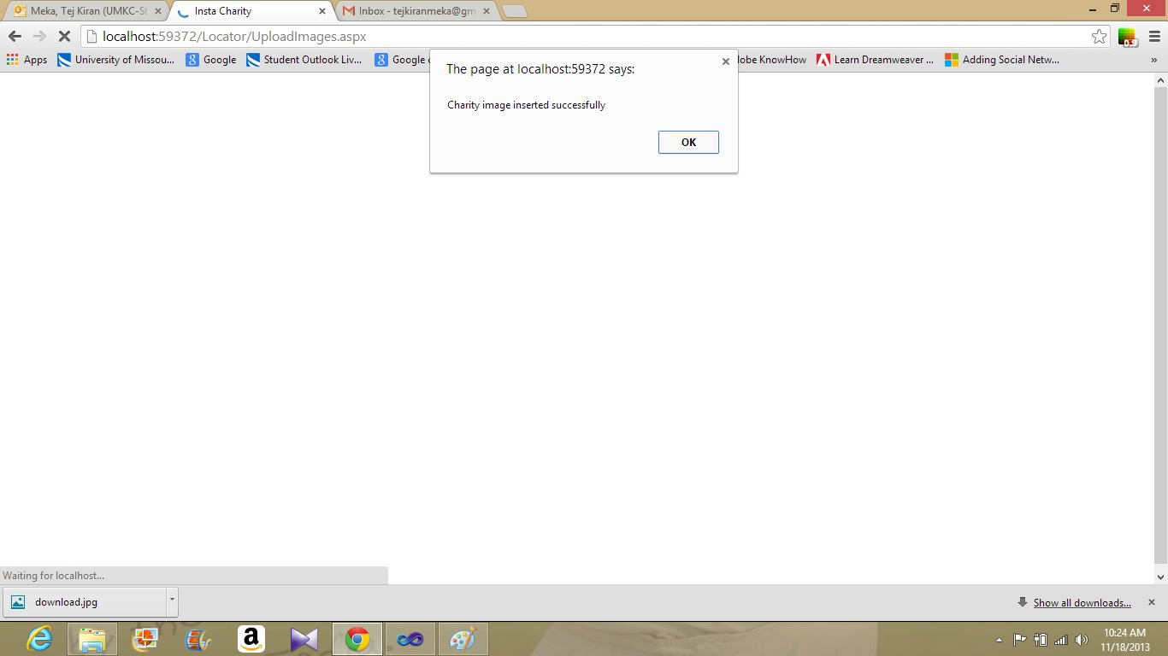

* **Project Management:**
* Implementation Status report:

By the end of the Increment 3 80% of the project is completed.

* Issues and concerns:

In 2nd Increment we implemented our project on html. We faced issues with compatibility in that. So implemented entire site with JQuery mobile. In our project we have issues with the display of places in yahoo maps. Issues with retrieval of images from data base. Images are retrieved by the display is not perfect.

* Work to be completed:

We are trying to make the display of events more dynamic. Working on the marking of events on the map.